Check Box and radio button

Radio buttons versus checkboxes

Many people confuse checkboxes and radio buttons. There is a fundamental difference between them. In a checkbox group, a user can select more than one option. Each checkbox operates individually, so a user can toggle each response "on" and "off."

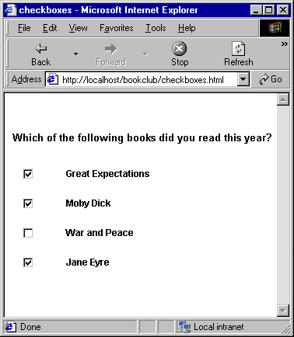

Radio buttons, however, operate as a group and provide mutually exclusive selection values. A user can select only one option in a radio button group.

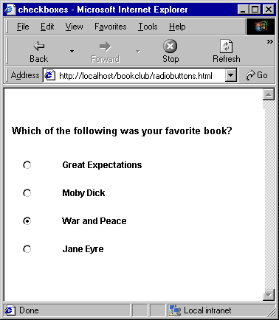

If you want to enable your user to select more than one option in a group of choices, use checkboxes. If you want to restrict your user to one option, use radio buttons.

Checkbox:

package Week2day2;

import org.openqa.selenium.WebElement;

import org.openqa.selenium.chrome.ChromeDriver;

public class CheckBox {

public static void main(String[] args) {

System.setProperty("webdriver.chrome.driver", "./drivers/chromedriver.exe");

ChromeDriver driver=new ChromeDriver();

driver.manage().window();

driver.get("http://leafground.com/pages/checkbox.html");

WebElement checkbox=driver.findElementByXPath("(//\*[@type='checkbox'])[1]");

boolean displayed = checkbox.isDisplayed();

System.out.println(displayed);

boolean enabled = checkbox.isEnabled();

System.out.println(enabled);

boolean selected = checkbox.isSelected();

System.out.println(selected);

checkbox.click();

System.out.println("checkbox is selected");

WebElement checkbox1= driver.findElementByXPath("(//\*[@type='checkbox'])[6]");

boolean displayed1 = checkbox1.isDisplayed();

System.out.println(displayed1);

boolean enabled1 = checkbox1.isEnabled();

System.out.println(enabled1);

boolean selected1 = checkbox1.isSelected();

System.out.println(selected1);

}

}

Radio Button:

WebElement radio1 = driver.findElement(By.id("vfb-7-1"));

WebElement radio2 = driver.findElement(By.id("vfb-7-2"));

//Radio Button1 is selected

radio1.click();

System.out.println("Radio Button Option 1 Selected");

//Radio Button1 is de-selected and Radio Button2 is selected

radio2.click();

System.out.println("Radio Button Option 2 Selected");